Lab 8

**Objective: To learn XML schema and parsing an XML document.**

**Task 1: Create an XML document structuring information for a store. (shopping store of your choice).**

**XML:**

**<atta_ul_momin>**

**<name>ShaikhHouse</name>**

**<fast_food>**

**<items>**

**<burger>Zinger Burger</burger>**

**<pizza>Italian Pizza</pizza>**

**<broast>Chicken Broast</broast>**

**</items>**

**</fast_food>**

**</atta_ul_momin>**

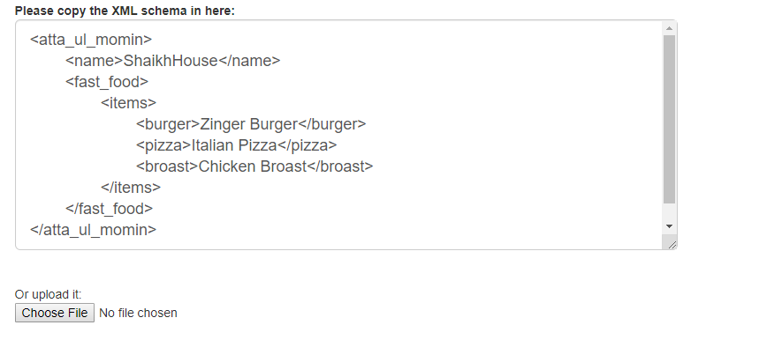**C:\Users\Usama Shykh\Desktop\Usama labs\task 2\8.1.PNG**

**Task 2: Create DTD for store XML Document. And validate on** [**http://www.w3schools.com/xml/xml_validator.asp**](http://www.w3schools.com/xml/xml_validator.asp)

**<?xml version=”1.0” encoding=”ISO-8859-1” ?>**

**<! DOCTYPE atta_ul_momin[**

**<!ELEMENT atta_ul_momin(name,fast_food)>**

**<!ELEMENT name (#PCDATA)>**

**<!ELEMENT fast_food(burger,pizza,broast)>** 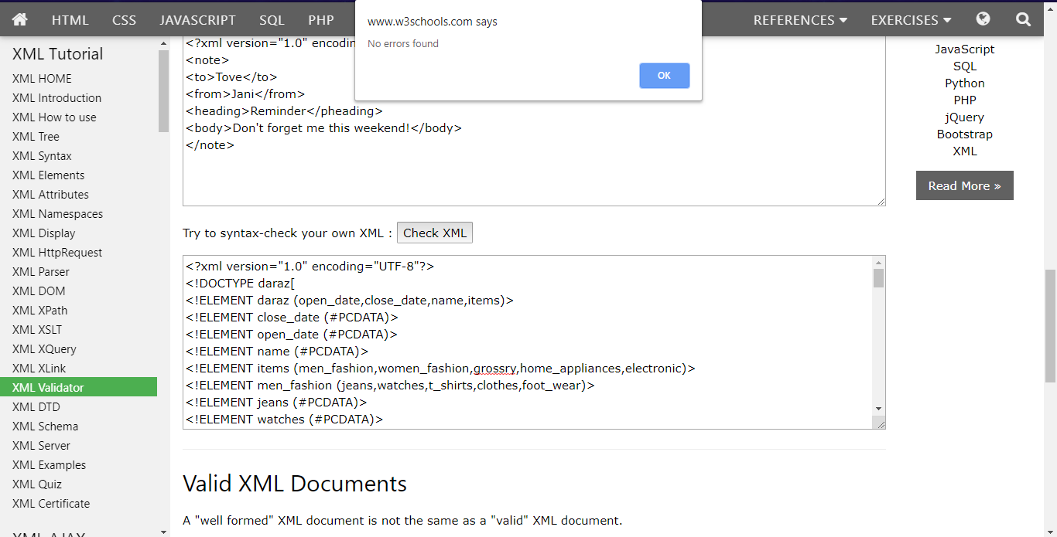

**Task 3: Write XML Schema for the following XML document and then validate the XML document along with its schema on the following website:**

[**http://www.utilities-online.info/xsdvalidation/#.UlFx2tKmhIg**](http://www.utilities-online.info/xsdvalidation/)

**<?xml version=“1.0” ?>**

**<movies>  
  <movie genre=“romantic">  
    <title lang="en">The Fantastic Four</title>  
    <year>1805</year>  
    <rating>5.8</rating>  
  </movie>  
  <movie genre=“Action">  
    <title lang="en">Impossible</title>  
    <year>1999</year>  
    <rating>9.9</rating>  
  </movie>  
  <movie genre=“adventure">  
    <title lang="en">Everest</title>  
    <year>2015</year>  
    <rating>7.4</rating>  
  </movie>  
</movies>**

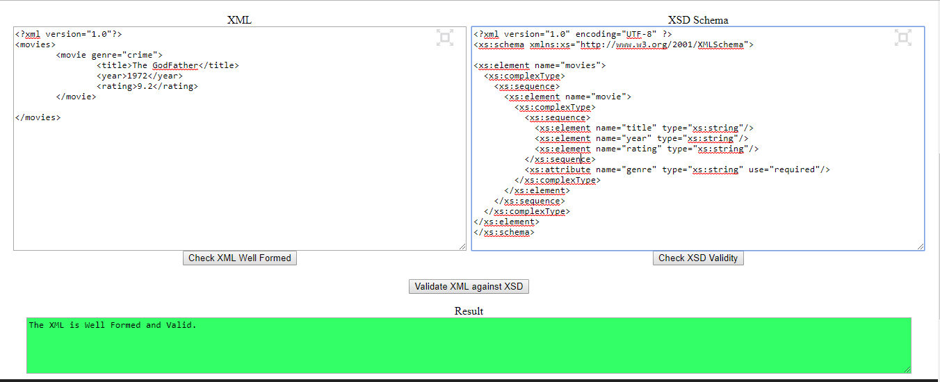

**Task 4: Write an XML instance for following schema and then parse that document in Java using either DOM or SAX API.**

**<?xml version=“1.0” ?>**

**<xs:schema xmlns:xs=“http://www.w3.org/2001/XMLSchema”>**

**<xs:element name="person“ type="persontype"/>**

**<xs:complexType name="persontype">  
<xs:sequence>  
 <xs:element name="firstname“ type="xs:string"/>  
<xs:element name="lastname" type="xs:string"/>  
<xs:element name=“date_of_birth” type=“date”/>**

**</xs:sequence>  
</xs:complexType>**

**<xs:complexType name=“date”>**

**<xs:sequence>**

**<xs:element name=“day” type=“xs:integer”/>**

**<xs:element name=“month” type=“xs:integer”/>**

**<xs:element name=“year” type=“xs:integer”/>**

**</xs:sequence>**

**</xs:complexType>**

**</xs:schema>**

**XML:**

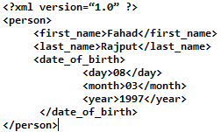

**Code:**

